Best places to open a restaurant in Dallas

# DATA

1. Competitor analysis.

If there are already three pizza restaurants on a street, you’ll want to think long and hard before opening a fourth. There are no hard and fast rules on what constitutes market saturation. However, a good rule of thumb is whether or not you believe that your restaurant could thrive without taking away a big chunk of business from another good restaurant.

We are going to use Foursquare location data to find where are most fast food restaurants are located.

1. Complimentary restaurants

Complimentary restaurants have concepts that are different from your restaurant, but their price points are often in the same range as your own. These complimentary restaurants help establish specific areas within a community that offer multiple eating options. Customers often seek out these areas to window shop and find what they’re craving in the moment. Sometimes your customers will eat with the complimentary restaurants, and other times they’ll eat with you. The benefit, however, is that complementary restaurants are less competitive than restaurants with the same concept as yours.

We are going to use Foursquare location data to find where are most fast food restaurants are located.

# Data Source

Getting the neighborhoods and the geo coordinates from [www.geonames.org](http://www.geonames.org)

URL: <http://www.geonames.org/search.html?q=Dallas&country=US>

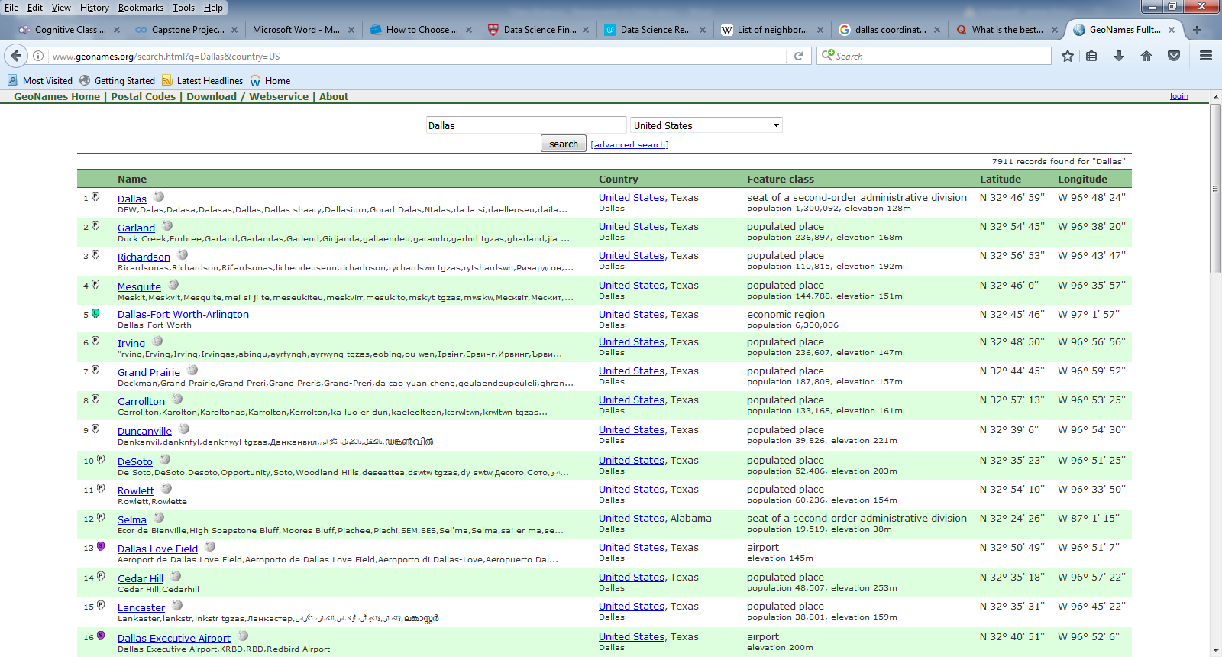

# Data Cleanup

On taking a closer look at the data imported from the web page we can see that there are various formatting issues which make the data unusable as is

1. Place the data in the appropriate columns

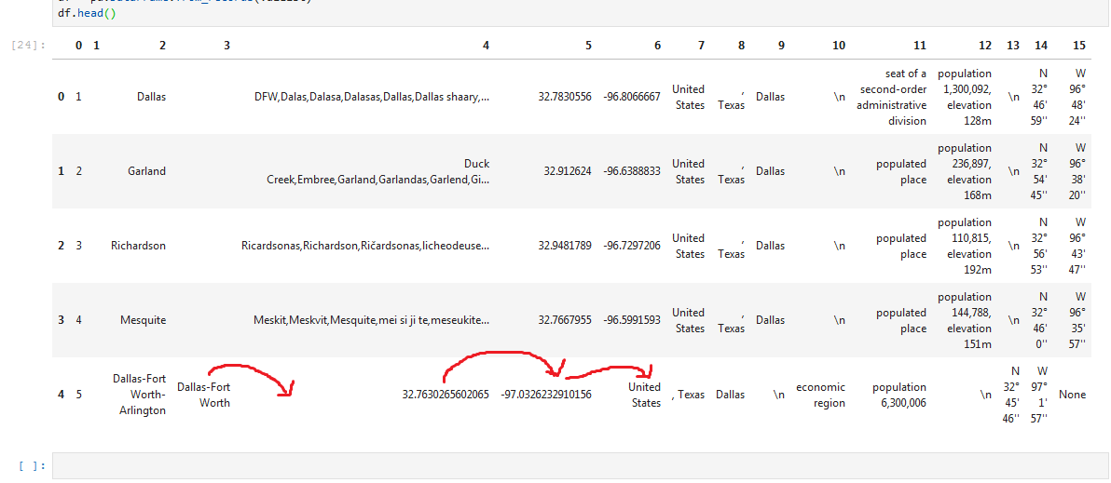

We can see in the above picture that in some rows (as the one highlighted above) the data needs to be moved to the next column.

1. Remove unnecessary data.

* There are some empty columns that need to be removed.
* Unnecessary columns such as Country and State need to be removed as we don’t need them

Final dataset after cleanup

